Tableau graphs and mappings based on dataset of proportion unemployed (per 1000) for persons of age 15-59 years according to usual status
by
G.Akhila Mtech CSE, gotteakhila11@gmail.com

- First i took a data set of unemployment.
- Import to tableau data source.
- created a horizontal bar graph based on rule , urban male and female to prepresent hight count of unemployment of perticular area base on gender. See the below figure1.
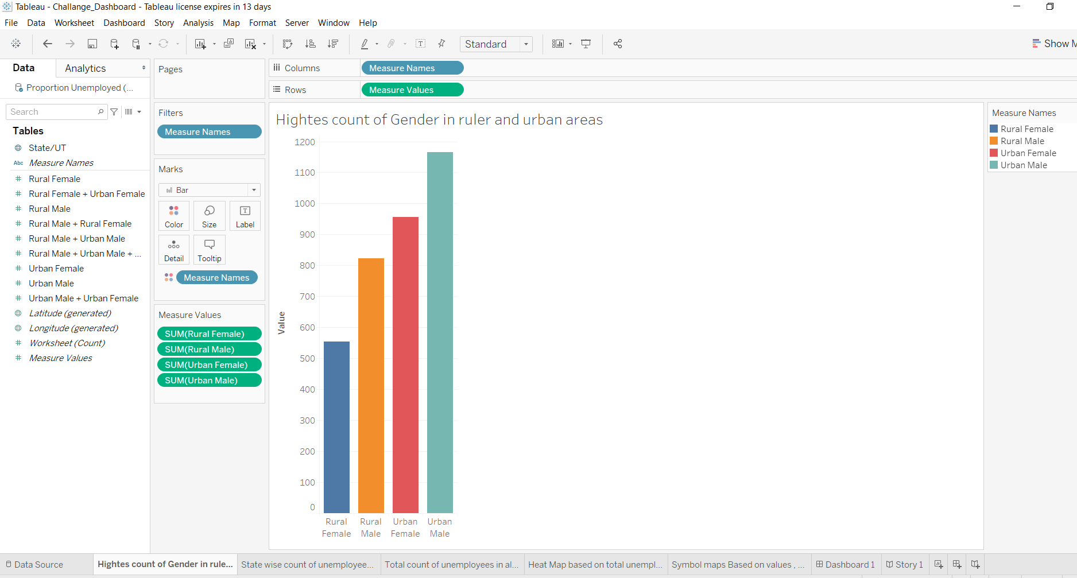
Figure 1

- Another graph represents about state wise count of unemployees in ruarl and urban areas, see the below figure 2.
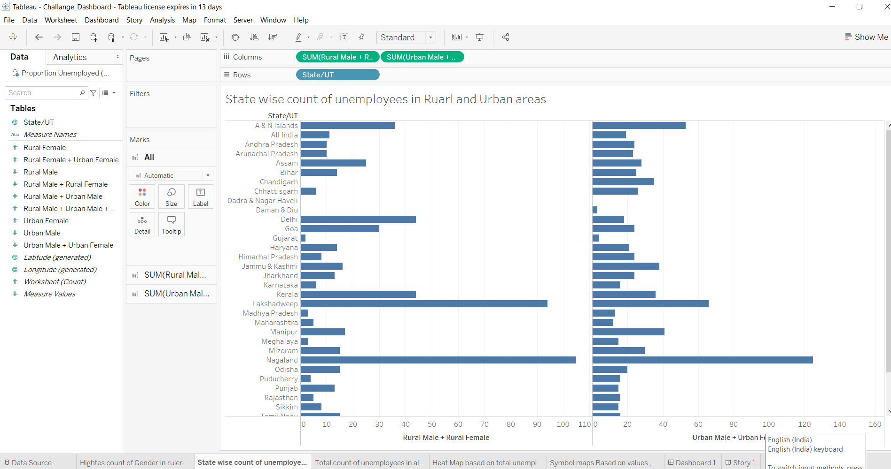
Figure 2
- Next 3rd graph is about total count of unemployees in all states, see the below figure 3.
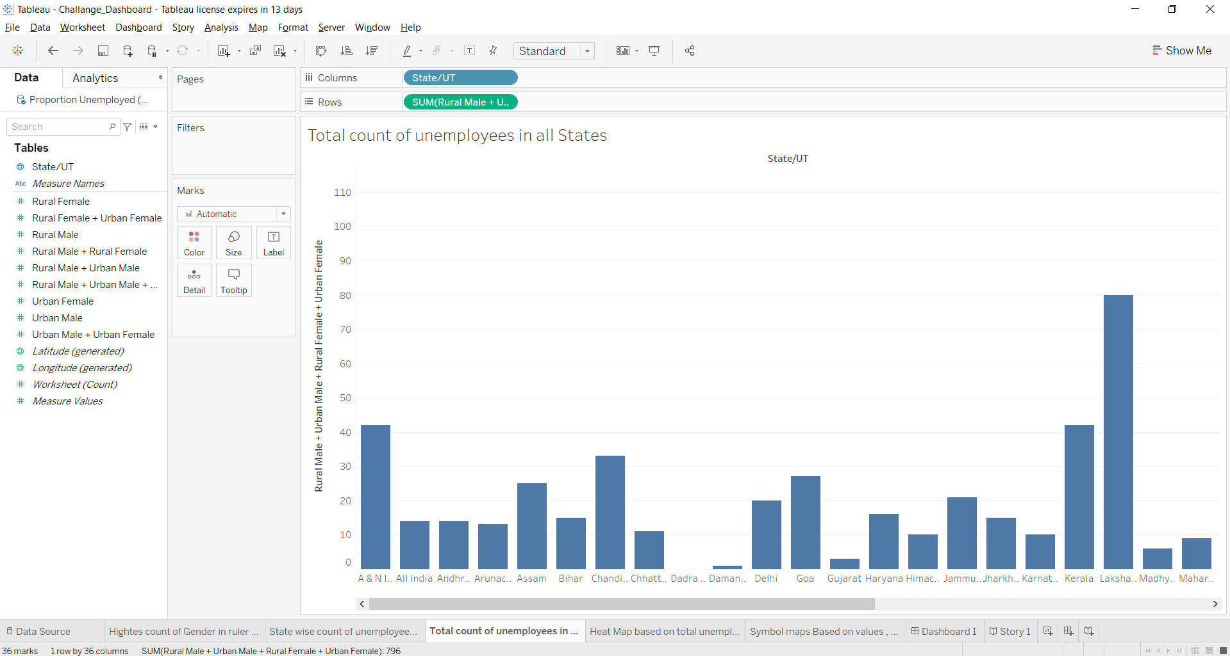
Figure 3

- Next created a heat map based on total unemployes on all states, see the below figure 4.
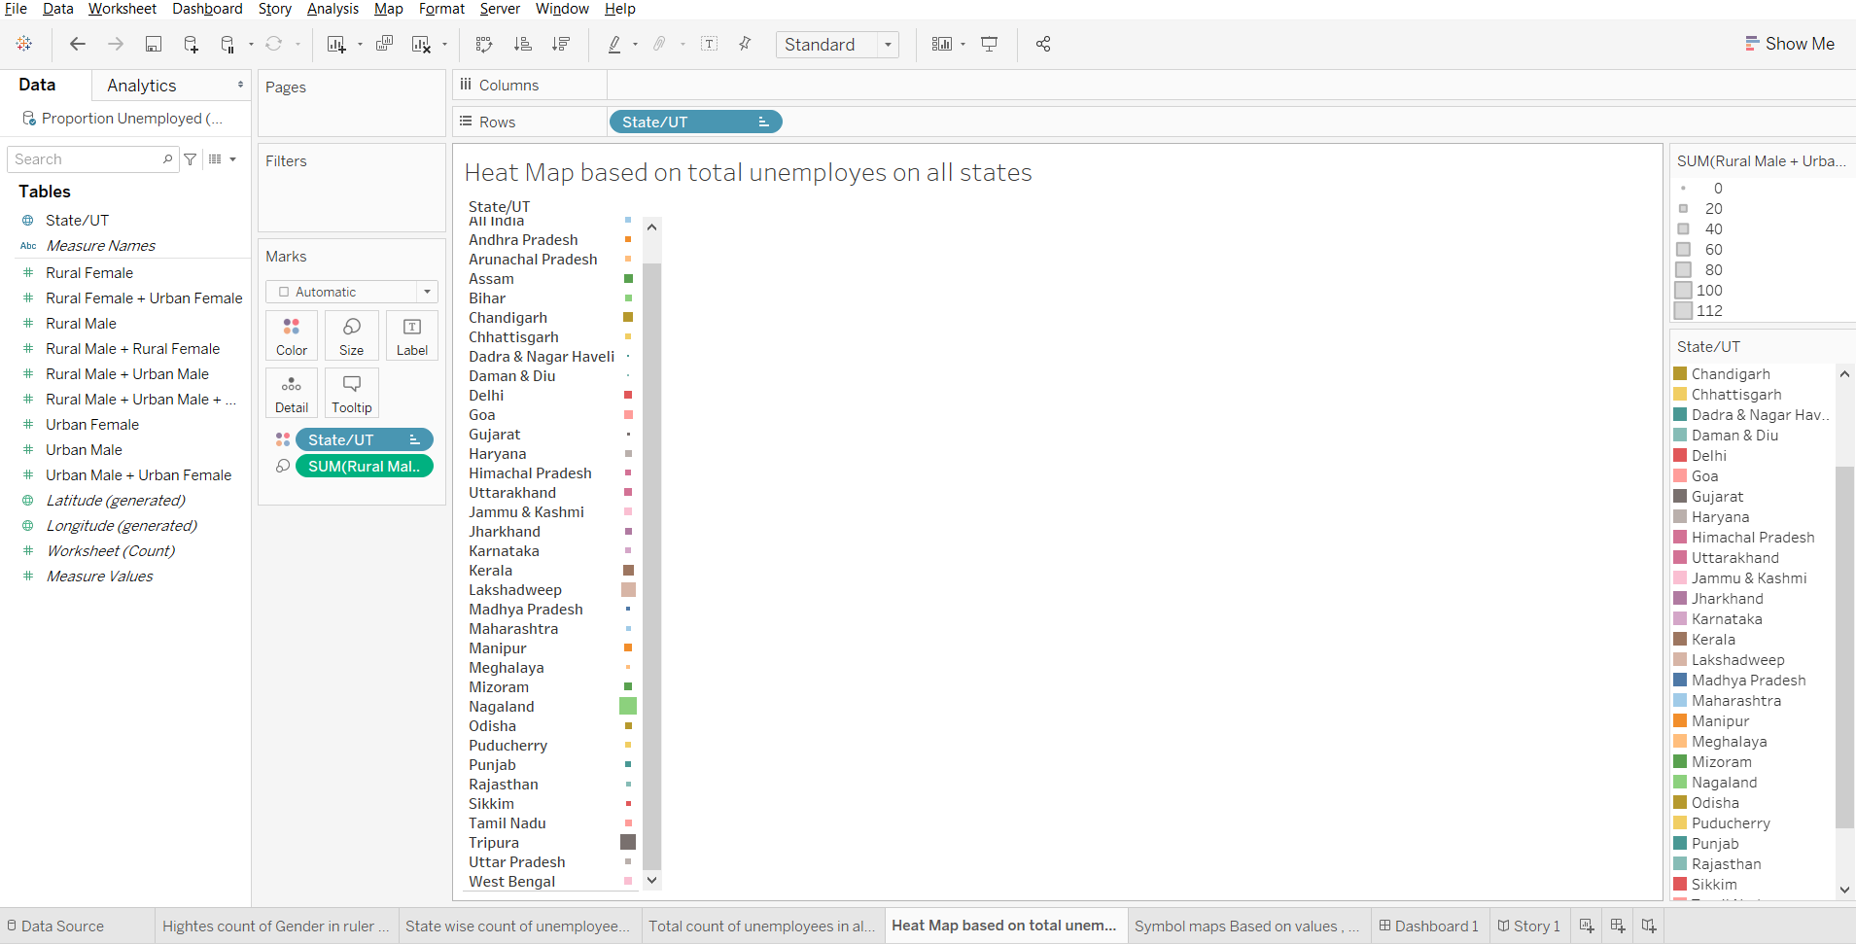
Figure 4
- Next created a symbol map which says about total unemployments based on values , names, see the below figure 5.
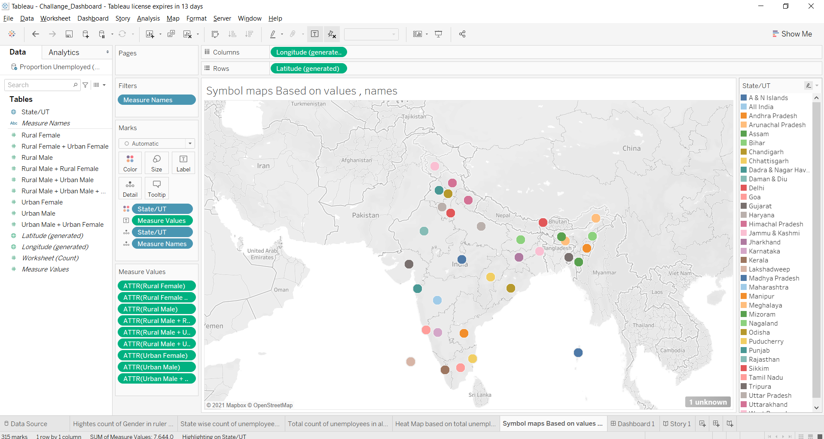
Figure 5

- Next created a dashboard of all graphs and maps. see below figure 6
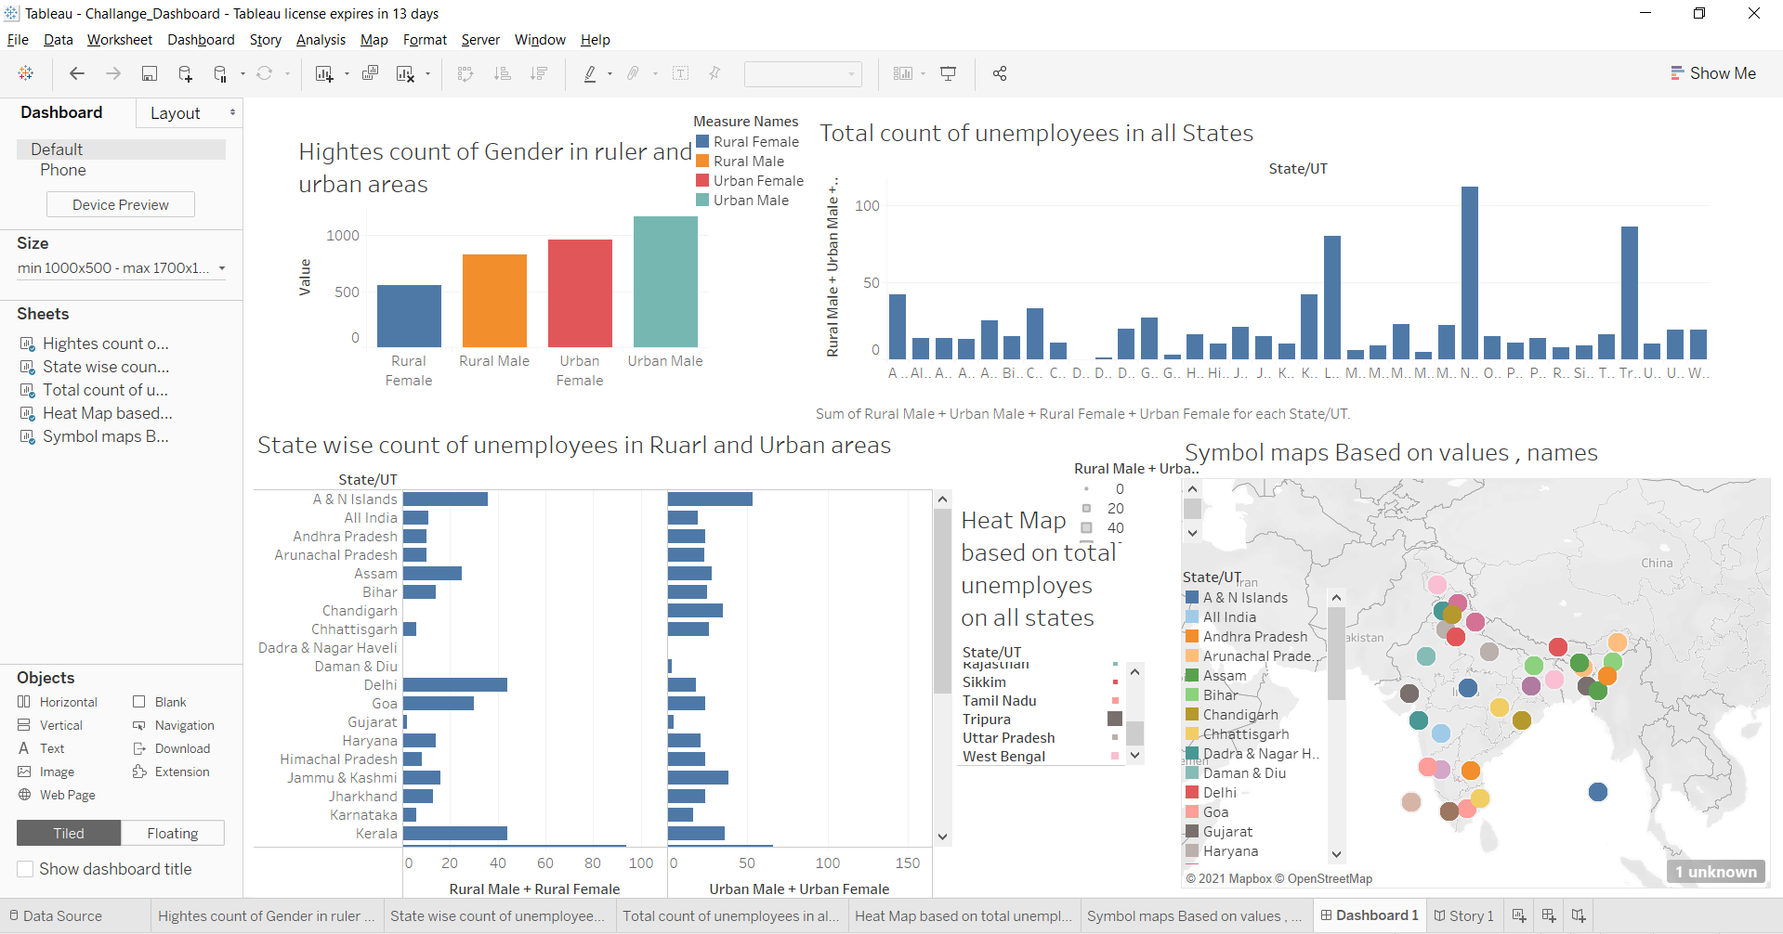
Figure 6

- Next created a story of all graphs and maps. see below figure 7
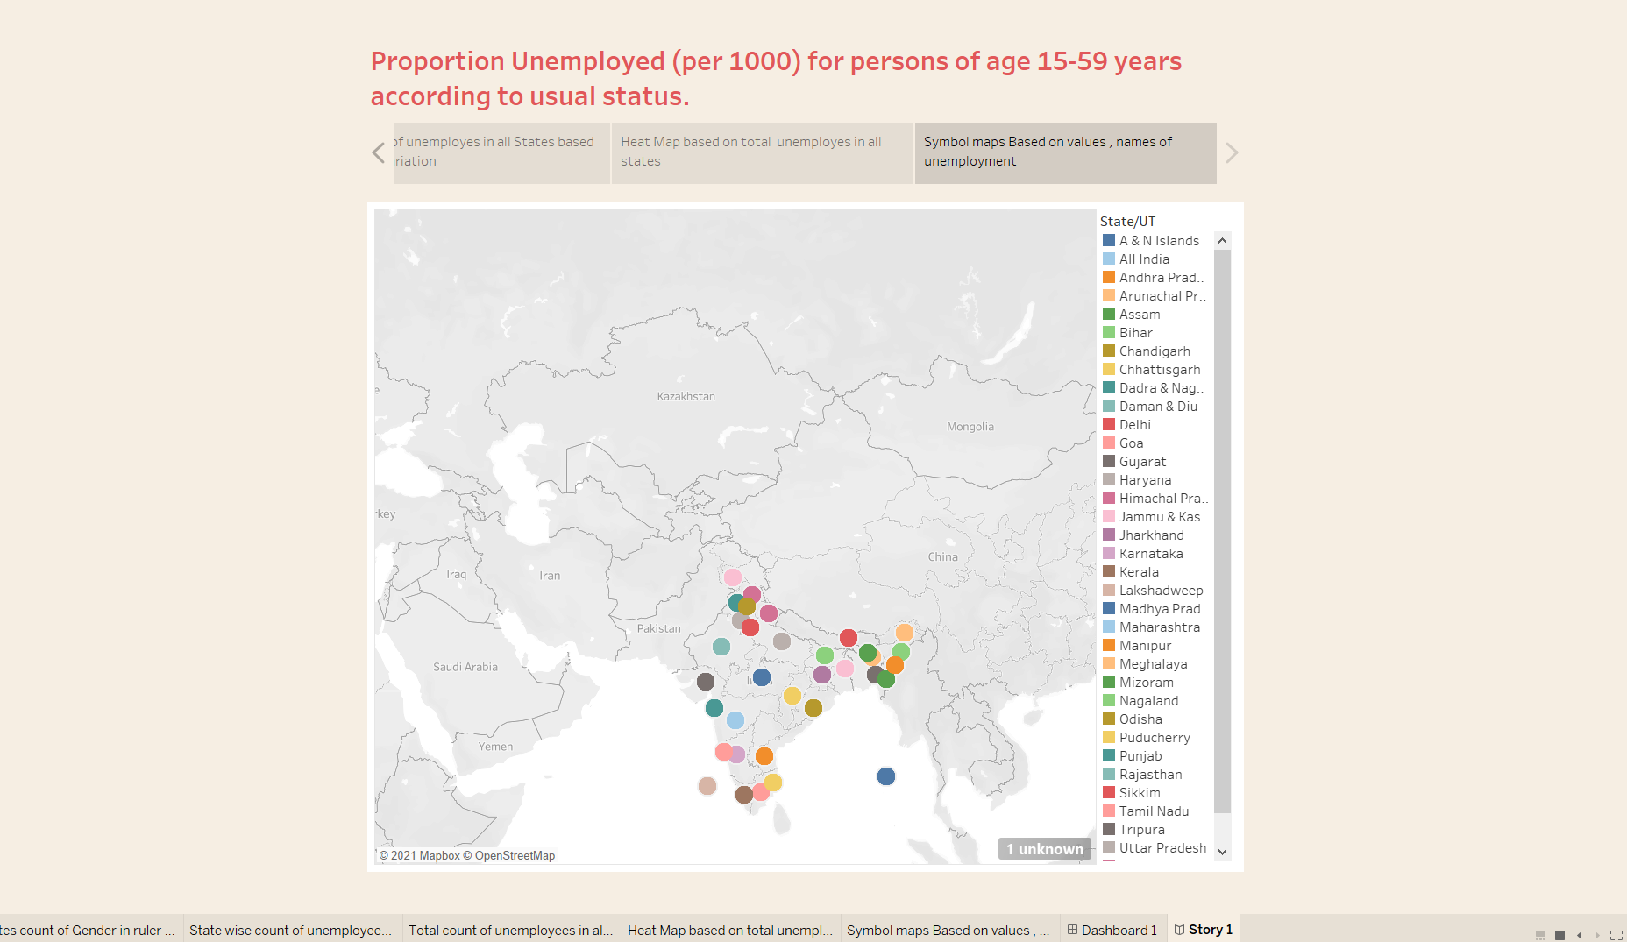
Figure 7
10. This project is all about the unemployment allover the states in india.
11. Github repository link https://github.com/AkhilaG11/Tableau_AkhilaG
12. Google drive link https://drive.google.com/file/d/1cKcc6OgUjxpz81tsuUXrJIzMOx3I8qU4/view?usp=sharing

